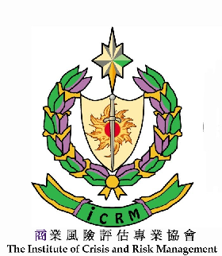
CISA EXAM READY WORKSHOP
Enrolment Form

I wish to enrol in

CISA EXAM READY WORKSHOP
Day 1: November 29, 2005 (Tuesday)
Day 2: November 30, 2005 (Wednesday)
Time: 9:30 a.m. to 12:30 p.m. and 2:00 p.m. to 5:00 p.m.
Venue: YMCA Hotel, Tsimshatsui, Kowloon, Hong Kong.
Course Fee: HK$5,000.00/4,500.00 (please delete as appropriate)
Enquiry: Tel (852) 3521 0798 Reservation : Fax (852) 2723 5862

Personal Details
Title: □Mr □Mrs □Ms □Miss □Dr
Name: (English) (Chinese)
Correspondence Address: □ Home □ Business (please tick as appropriate)

Telephone: E-Mail:

Business Details

Organization:
Position:

Education /Professional Memberships

Highest degree: Years of Work Experience:

Payment Method

By Cheque : Please make your cheque payable to the “The Institute of Crisis and Risk Management” and mail to “The Institute of Crisis and Risk Management (Attn: Mr. Ben Ho), Unit 2002, 20/F., Tower A, New Trade Plaza, 6 On Ping Street, Shatin, Hong Kong”.
I hereby to confirm all the above information filled in is correct:

__________________________________
Signature & Date

